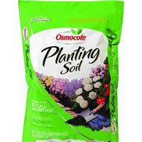
Osmocote Planting Soil

- 1 Cubic Foot
#1

- Enriched with plant food
- Feeds up to 6 months

$7.99
7269467

